Open Operations ManagementOutboundOrders
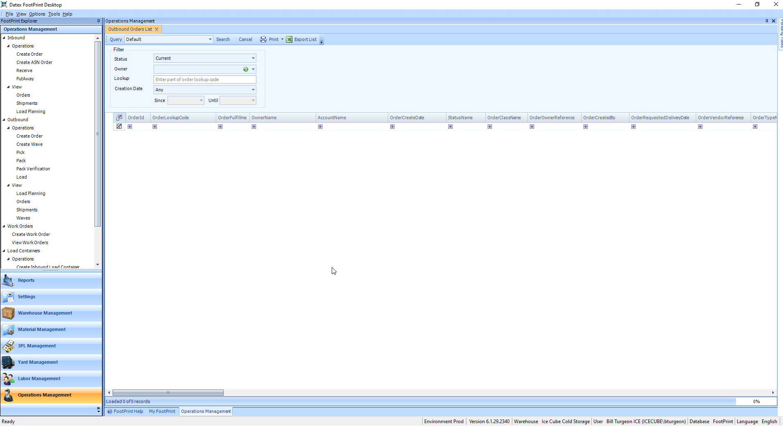

Select Owner = Goodgrain Inc. DBA Wildgrain, select Creation Date = Today, then click on Search.
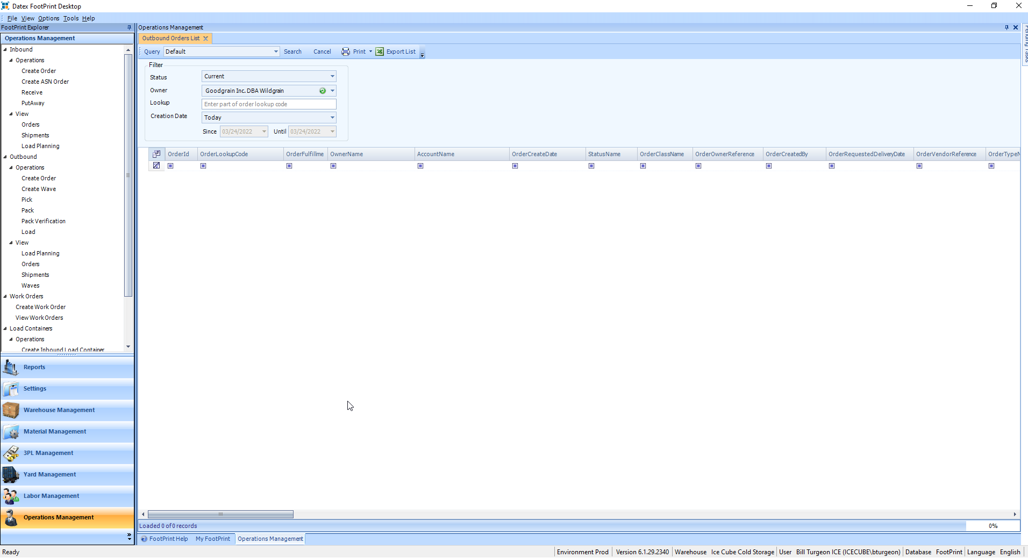

Note how many orders came in. In this example, there were 30 orders.
Click on OrderClassName Heading to sort them.
Note the first order has a OrderClassName = Sales Order.
We only care about OrderClassName = Wildgrain, so we only have 29 orders.
Make sure all OrderClassName = Wildgrain orders have a status of “Processing’
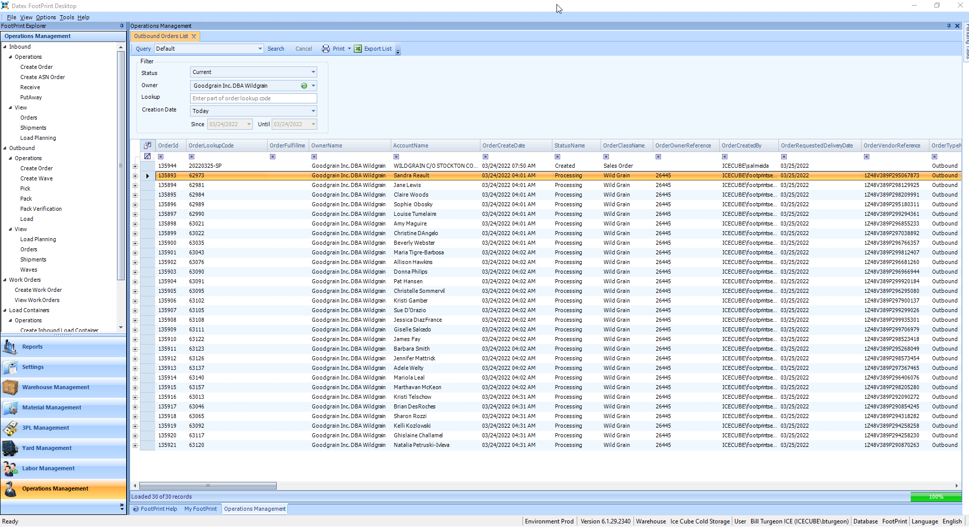

Go to your Browser and open https://api.wildgrain.com/icecube/today.
The file name tells you how many labels are contained in it.
For example, WG_03242022_23_40_label.pdf, has 23 labels as indicated by the highlighted text.
Adding these numbers together gives 29, which matches our total.
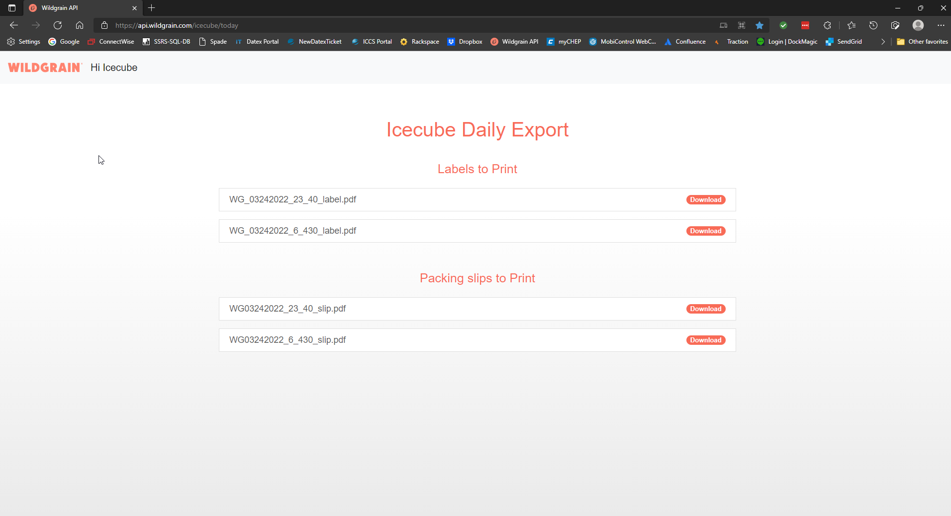

Go to ReportsOutbound ShipmentsWild Grain Shortage Report
This will show you any materials that we do not have enough of to fill the orders.
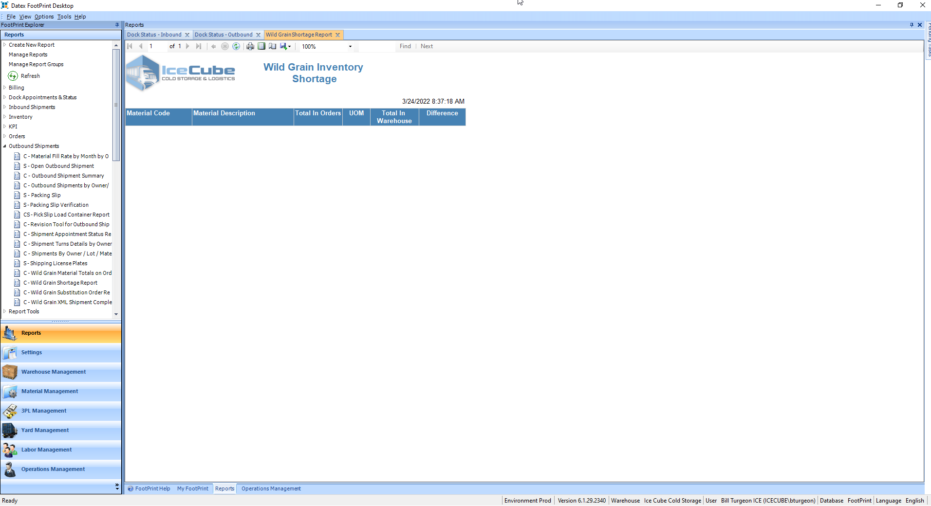

Go to ReportsOutbound ShipmentsWild Grain Material Totals on Order
Leave the dates as is, then Click in Select All, then View Report.
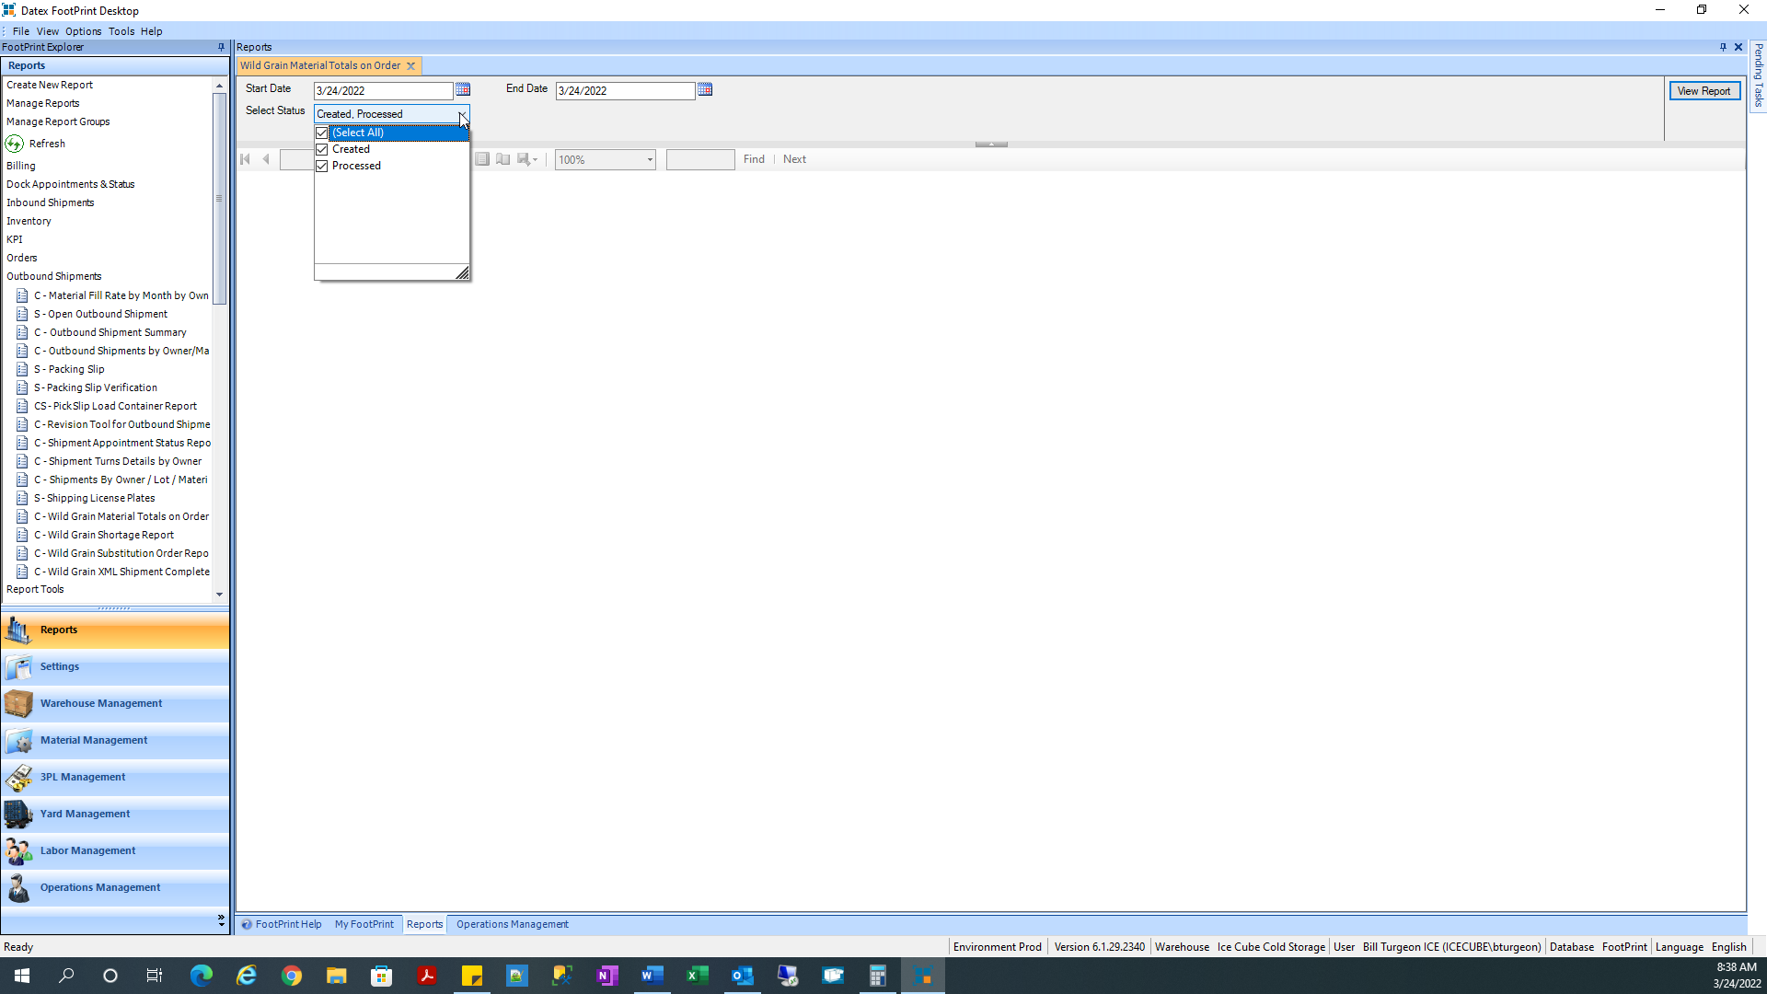

This will give you the total required for each material on the orders.
This report should be printed and given the person performing the Batch Pick.
When the material is brought to the staging area, a different person should count all the materials to ensure the totals match the required counts.
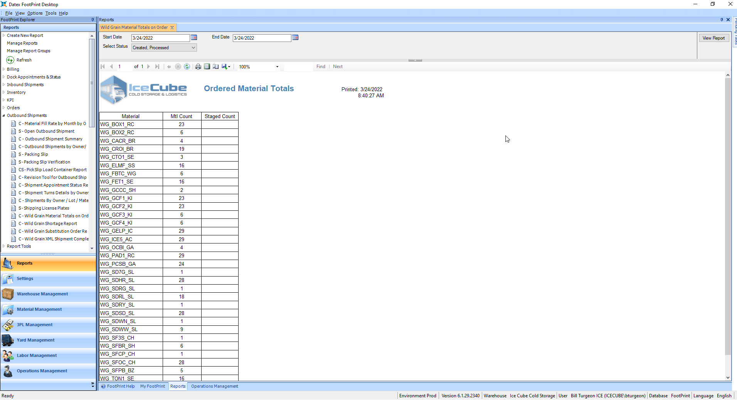

Go to Rules EngineSettingsView/Edit Rules
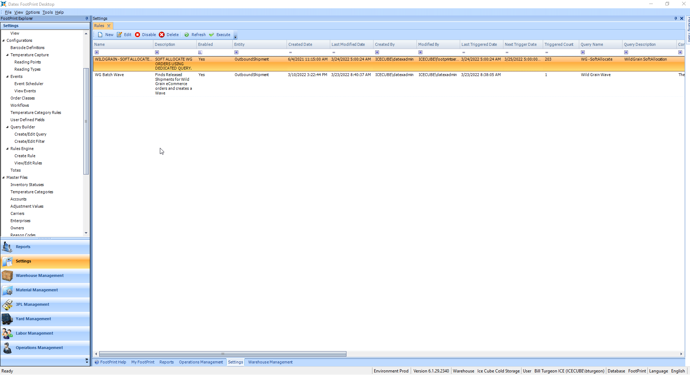

If any of the OrderClassName = Wildgrain orders have a status of ‘Created’, right-click on the top rule, WildGrain – Soft Allocate, the choose ‘Execute’ from the Drop-Down menu. This will process the orders and change the status to ‘Processed’.
This will take a few minutes to run. Go back to Operations ManagementOutboundOrders, and keep hitting Search every few minutes until all the OrderClassName = Wildgrain order have a status of ‘Processed’.
Once all have a status = ‘Processing’, go to the next page.

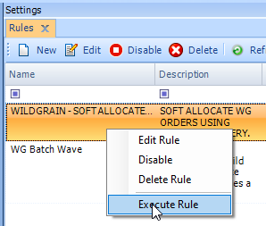

Go to ViewWarehouse Explorer
Enter in wg, then hit search.
Find a staging area with no inventory to use for the wave.
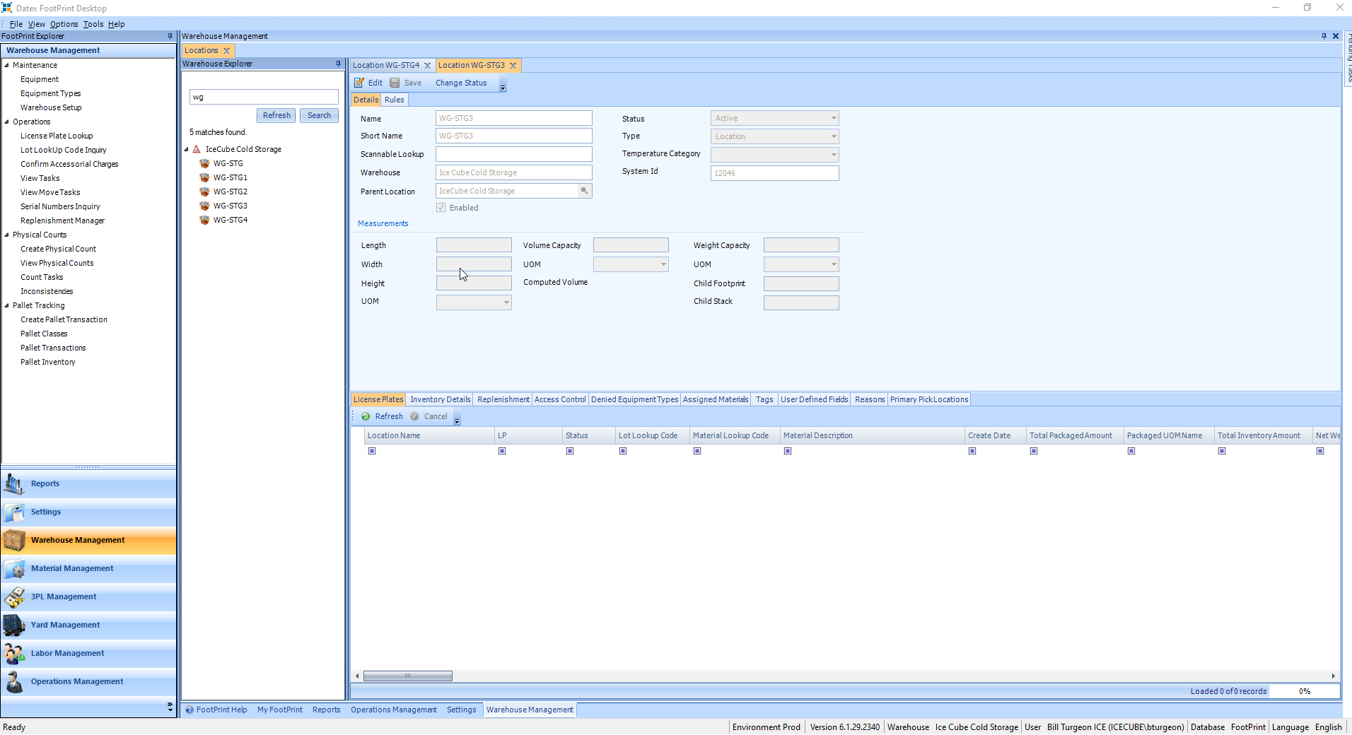

Go to SettingRules EngineView/Edit Rules


Right-Click on WG Batch Wave, then choose Edit from the list
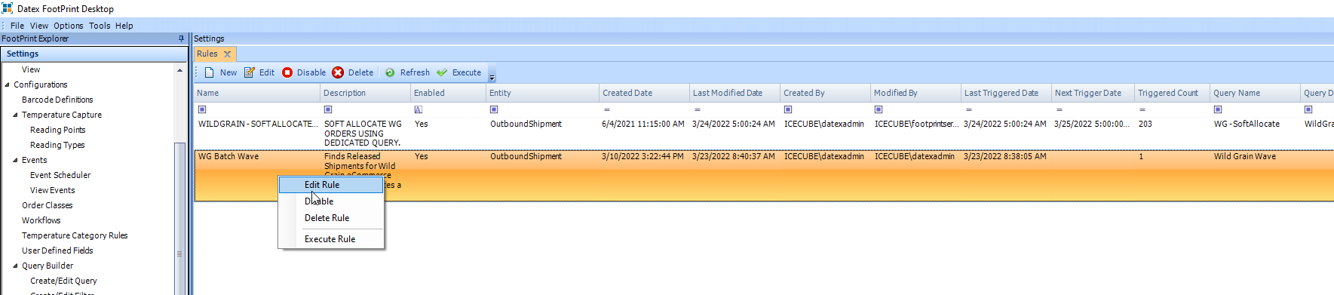

Select Edit as shown below.
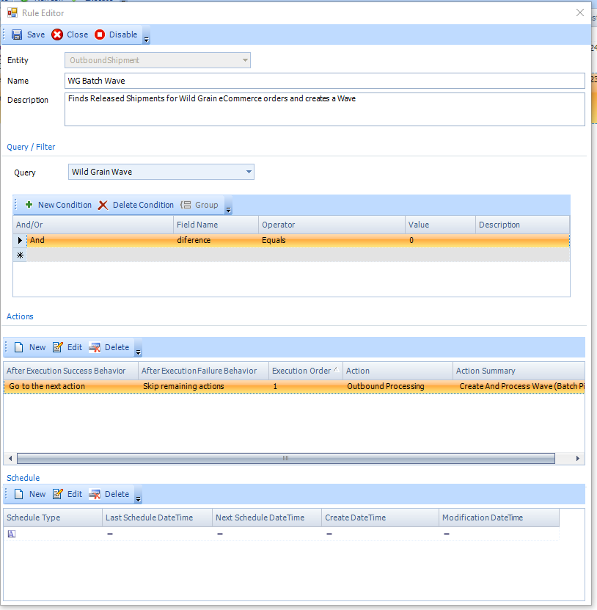

Click the mouse in the location to bring up the selection box
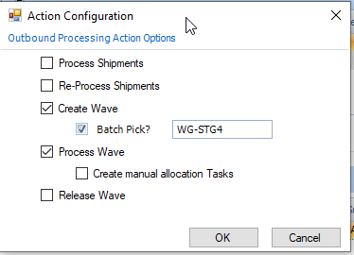

Type W in the box to go the first location starting with W
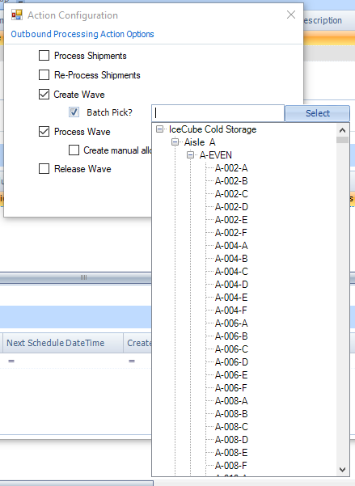

Select the staging area for this wave, and click on Select.
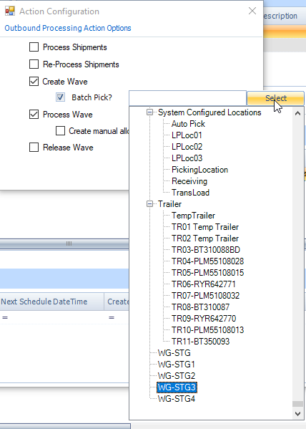

Click on Save, then close.
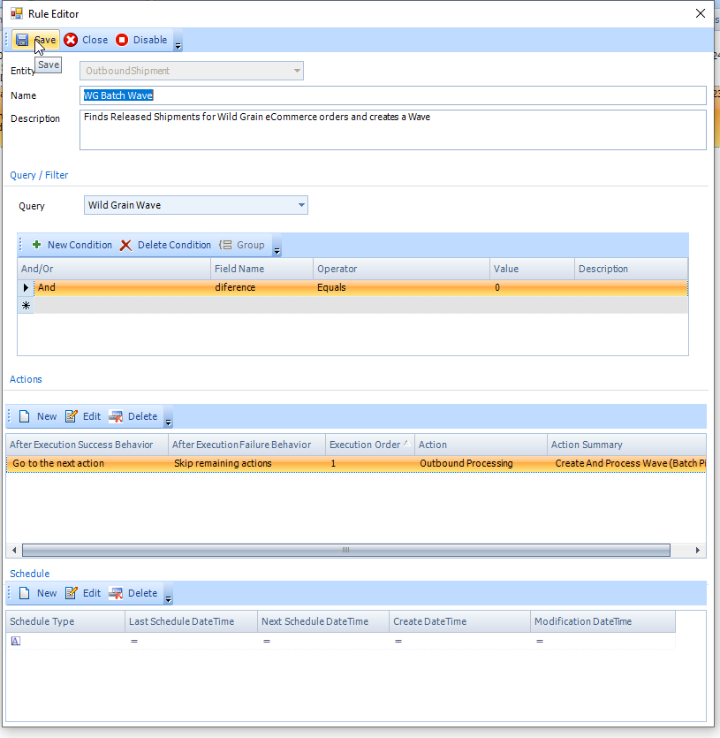

Right-Click on WG Batch Wave, then click on Execute Task.
Now go print your labels while the wave is being created and processed.
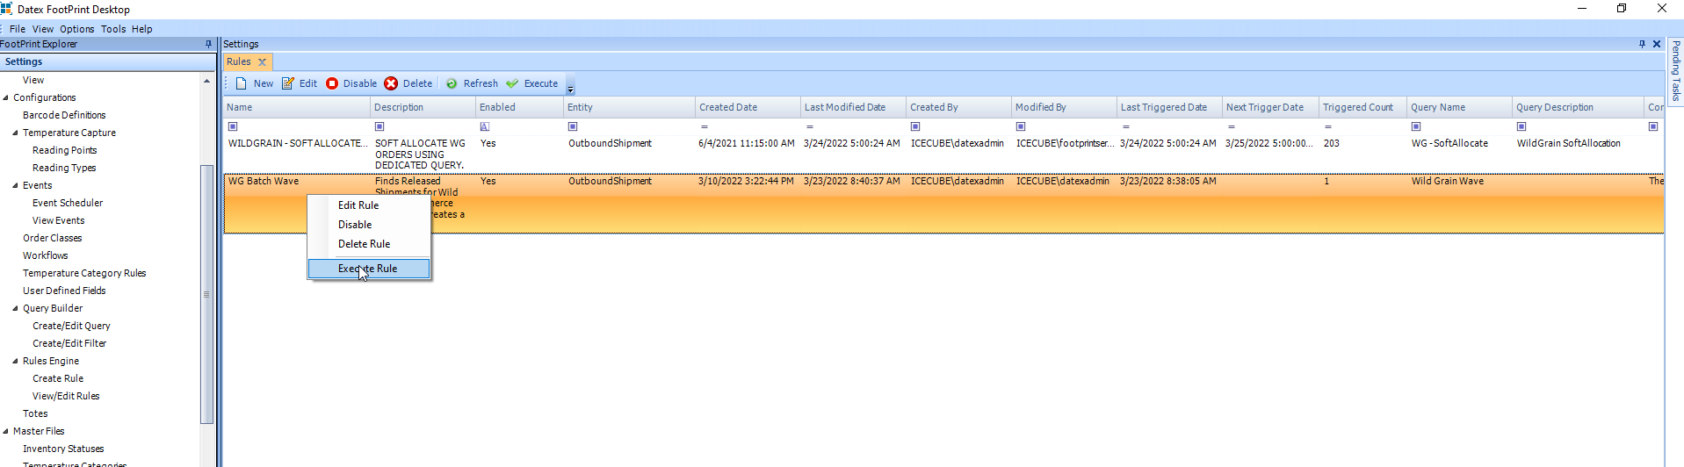

Go Operations ManagementOutboundViewWaves
Select Owner = Goodgrain Inc. DBA Wildgrain, then click on Search.
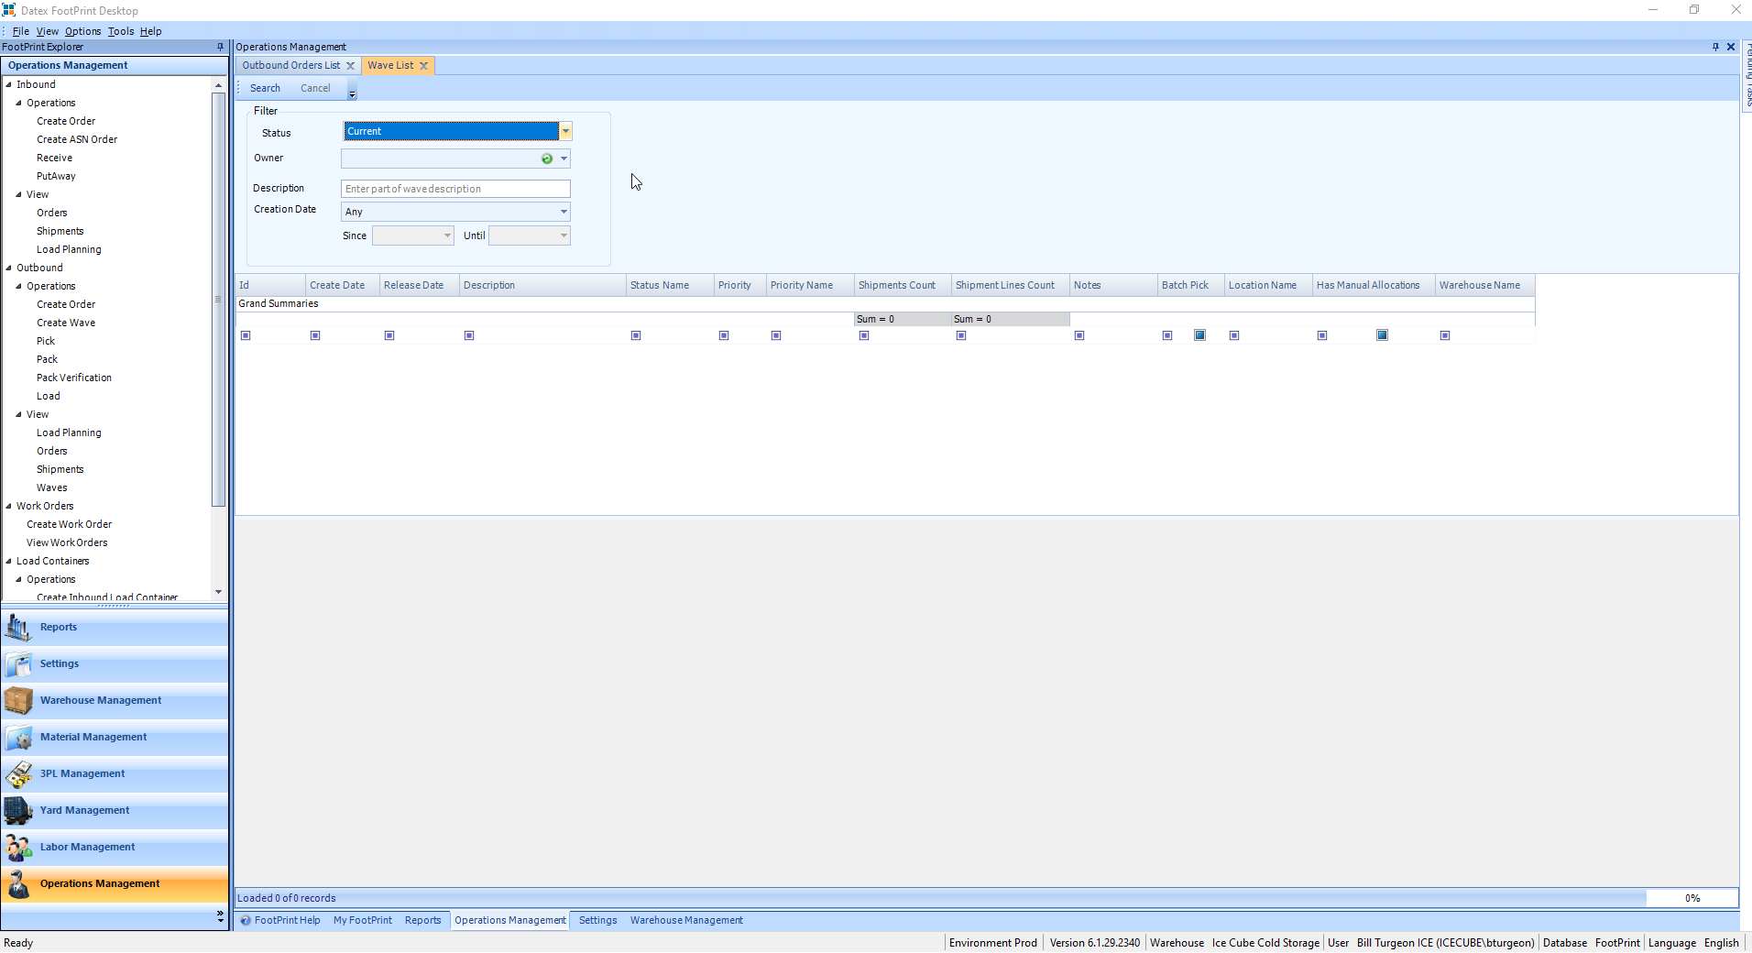

You should see the newly created Wave. Id the Status Name is ‘Processing’, the wave is not ready yet.
You can click on search every few minutes until the status changes to ‘Processed’, meaning it is done.
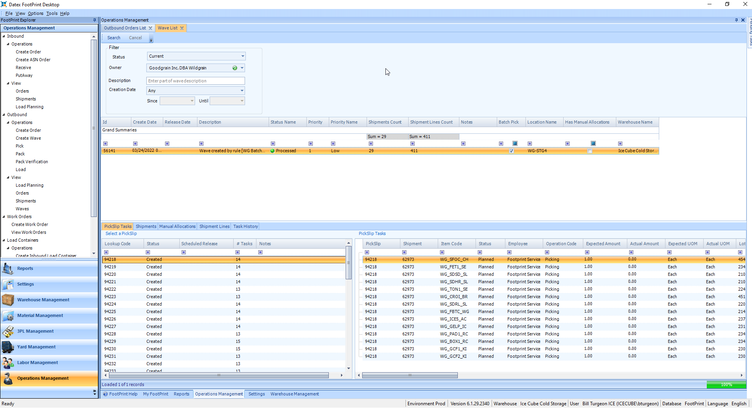

To release the wave, right-click on the wave, and choose Release
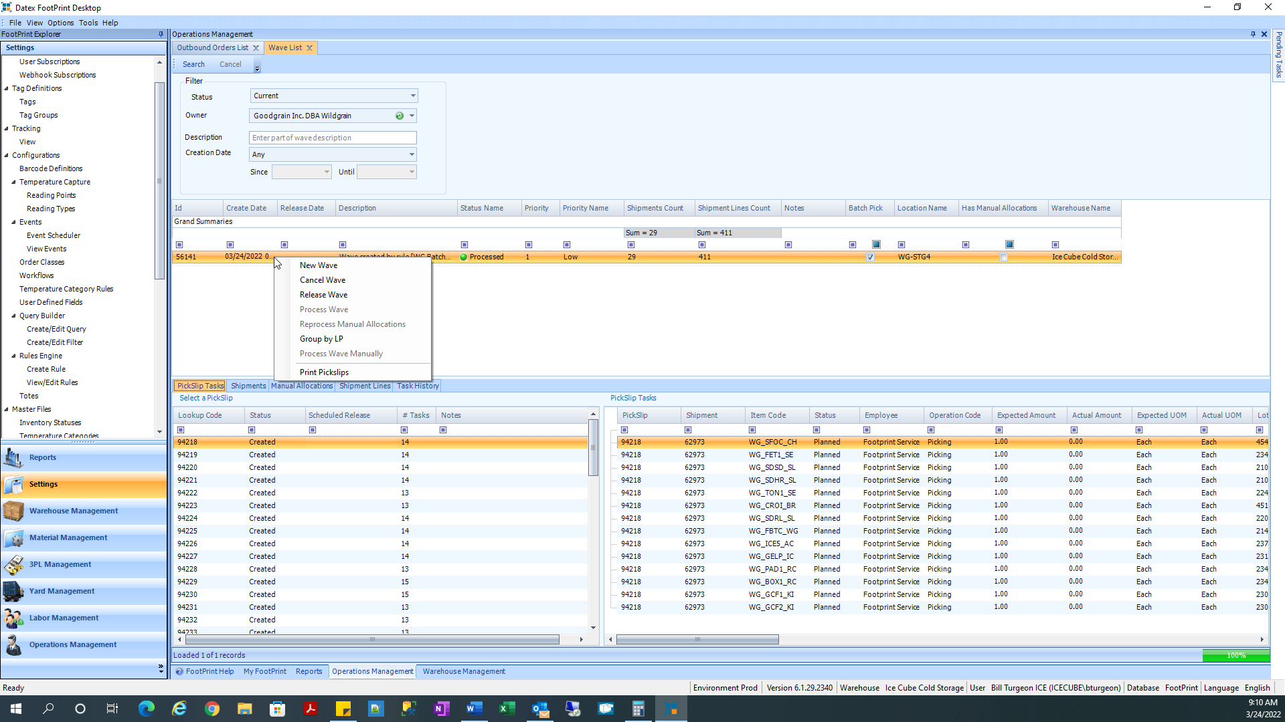

The Status Name will change to Released when done.
You are now ready to perform the Batch Pick.
